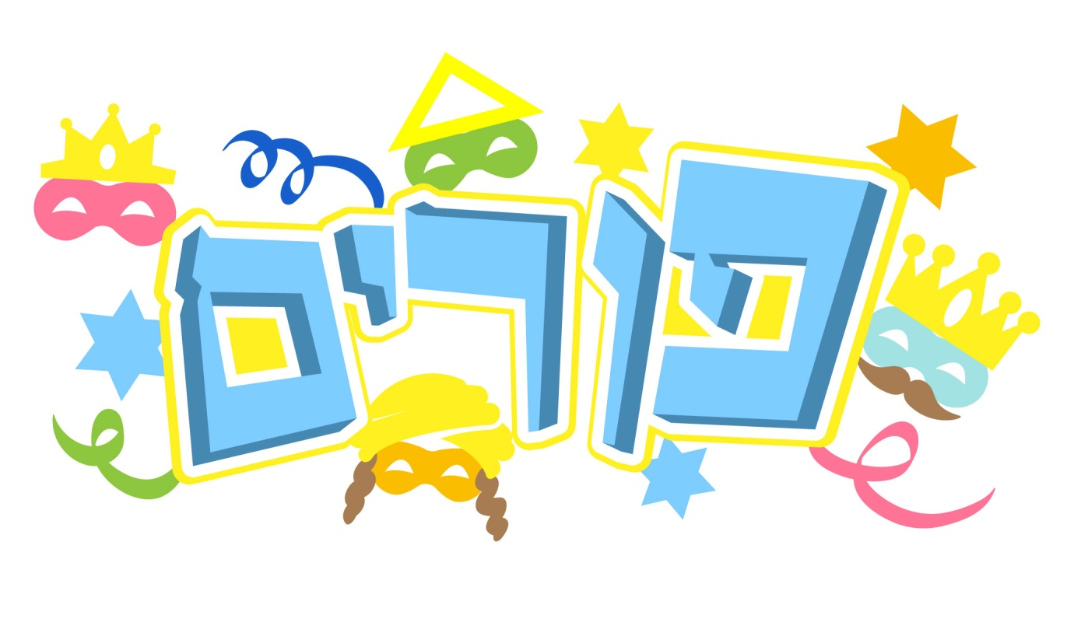
5775 IN NORTH HENDON
TAANIS ESTHER
Mincha & Krias Hatorah 5.15pm
Fast ends & Maariv 6.26pm
Megillas Esther First Reading by Joey Joseph 6.45pm
Megillas Esther Second Reading by Avi Joseph 9.00pm
PURIM
Shacharis First Minyan 6.30am
Megillas Esther First Reading by Keith Goldstein 7.10am
Shacharis Second Minyan 8.15am
Megillas Esther Second Reading by Joey Joseph 8.55am
Yeshivas Mordechai Hatzaddik 3.00pm
Shiur by Rabbi Cohn 3.45pm
Mincha 4.00pm
Maariv 8.00pm
NOTES: The “plate” collections of Machatzis Hashekel, Matonos La’evyonim and Kimcha D’Pischa will be available in Shul on Purim evening and daytime. It is correct to wear Shabbos clothes for the reading of the Megilla and on Purim.

